At the begining I want to say a few words about topic that I chosen, in my home university when I just got in, my coordinator told me that our university uses international grading system GPA, but as she and other professors told me that GPA system in our university quite different compare to other countries. First of all, it rounds points just like every other university, but it rounds slightly differ than them, it rounds them not to bigger number but to lower number for example, if I have 75,5 points instead of rounding it to 76, our system rounds it back to 75 and when I first came to this university I though it's going to work just like in my home university. And thats why I got really confused when I first got here, so when I started fully understand how local system works I wanted to implement this solution to once and for all get fully understanding of GPA grading system.

As an example I took this tablet of points, their GPA and grade values

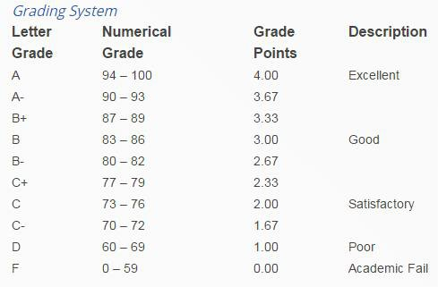

The grade-point-average is the arithmetic mean of the grade points earned for all credits taken at the University of Arizona for [University Credit](https://catalog.arizona.edu/key-course-descriptions) or by [Special Examination for Grade](https://catalog.arizona.edu/policy/proficiencycompetency-and-exemption-examinations-special-examination-credit-or-grade), where regular grades are awarded. Ordinarily cumulative GPAs are calculated using only the courses at the career level of the student. For example, the undergraduate GPA is based on undergraduate courses only (see [Graduate Credit for Seniors](https://catalog.arizona.edu/policy/graduate-credit-seniors), [Grade Replacement Opportunity](https://catalog.arizona.edu/policy/grade-replacement-opportunity-gro), and [Second Start](https://catalog.arizona.edu/policy/second-start-readmission-policy), [Academic Renewal for exceptions](https://catalog.arizona.edu/policy/academic-renewal-undergraduate-students)).

Only [regular grades](https://catalog.arizona.edu/policy/grades-and-grading-system) (A, B, C, D, E) are included in the calculation of the grade-point-average. To calculate the GPA, the unit value for each course in which a student receives one of the above grades is multiplied by the number of grade points for that grade. The sum of these products is then divided by the sum of the units.

GPA = $\frac{Sum (module credit units X module grade point)}{Sum (module credit units)}$

So I created program with small amount of data in it to mathematically calculate GPA (or average points) of pre-added students. To make it I first of all, created list of GPA symbols and their values(like A=4.0, B=3.0 and etc.), then I added loop that calculates grades. After that I added few lists of grades at the bottom as an examples

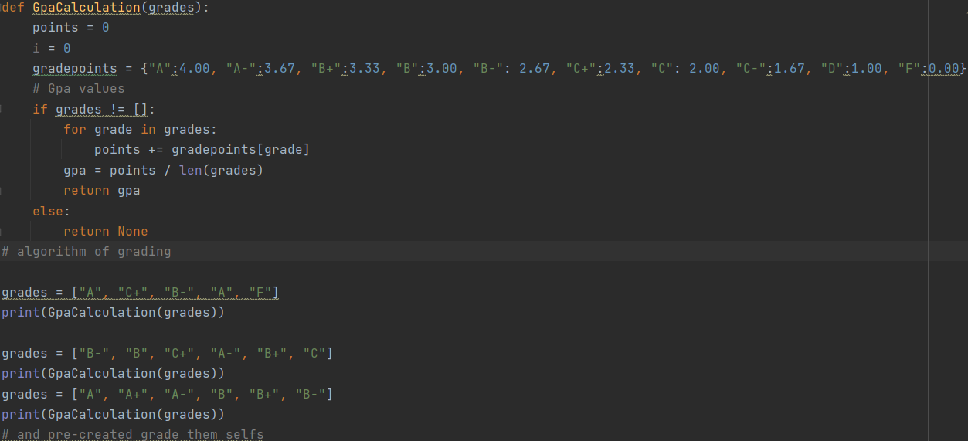

Reference

https://catalog.arizona.edu/policy/grade-point-average-gpa-calculation-or-averaging-grades

<https://edusteps.com.ua/blog/obuchenie-v-usa/860-kak-poschitat-svoy-gpa.html>

(site in Russian because, it’s more understandable for me)